## **CASE STUDY: purchase of parts in a manufacturing company**

1. Production asks Warehouse for raw materials
2. Warehouse has not the RM and forwards a request to the Purchase office
3. Purchase office negotiates with the chosen supplier, price, quantity, and delivery; issues the order and sends a copy to the accounting department
4. The Supplier delivers the materials to the warehouse together with the relative delivery note
5. Warehouse checks the received materials and sends a report to Quality Assurance concerning the compliance with the order specifications.
6. Warehouse returns possibly defective goods (RM) to Supplier
7. Accounting receives copies of the delivery notes and the amount of returned materials
8. Supplier sends invoice to Accounting
9. Accounting checks the invoice (compare with ordered and delivery note) and ask Finance to proceed with payment.
10. Finance execute payment to supplier
11. The warehouse sends the materials to Production that can start operations
12. Manager checks..

Full Case description: see slides 01Definitions.pdf, 54 to 64

## Organizational model

Manufacturing Company

Warehouse

Purchase office

Accounting

Finance

Quality office

Production

Supplier

## Process model

TEXT

Receive RM request

Receive RM from supplier

Purchase RM from supplier

Monitor RM status / decide repurchase

Select supplier

### Processes

#### TABLE Version

|  |  |  |  |  |
| --- | --- | --- | --- | --- |
| Process name | Input | Output | description | Organizational unit involved |
| Receive RM request | RM request | RM available for pick up | Analyze request, collect RM in warehouse, prepare for transport, record pick up, notify RM ready to entity who requested it | Warehouse |
| Purchase RM from supplier  (certain RM is associated to certain supplier) | RM repurchase decision | RM delivered by supplier | Find supplier for RM, notify accounting, send order to supplier, record RM delivered | Supplier, accounting |
| Select supplier | Select supplier decision for RM | Supplier for RM is defined, contract with supplier is signed | For a given RM find all possible suppliers, contact them asking offers, select the supplier that provides best conditions, sign deal with supplier | Purchase office (legal office) |
| RM Quality check and storage | RM delivered | RM accepted and stored in warehouse, or RM rejected | Start quality check, if positive store RM in warehouse, record position and quantity of RM, notify accounting , produce quality report ,  If negative reject material, notify supplier, notify accounting | Quality office, warehouse |
| Process invoice | Invoice received by supplier | Invoice paid | Find the order corresponding to the invoice, verify correct (order received, all RM accepted), pay invoice | Accounting finance |
| Delivery | RM available for pick up | RM delivered | Transport from warehouse to production, record transport | Warehouse, production |

#### BPMN

#### Receive RM Request

(two possible options, without pools and lanes)

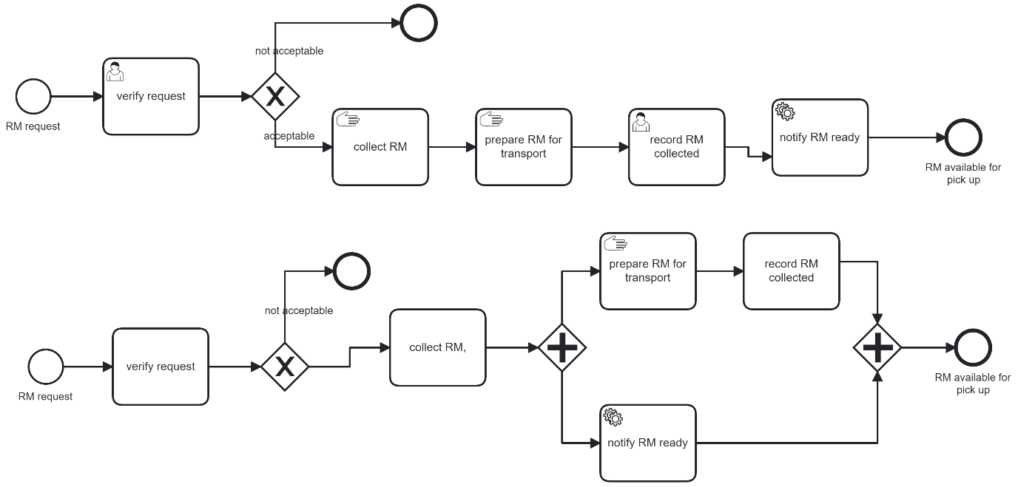

##### Purchase RM

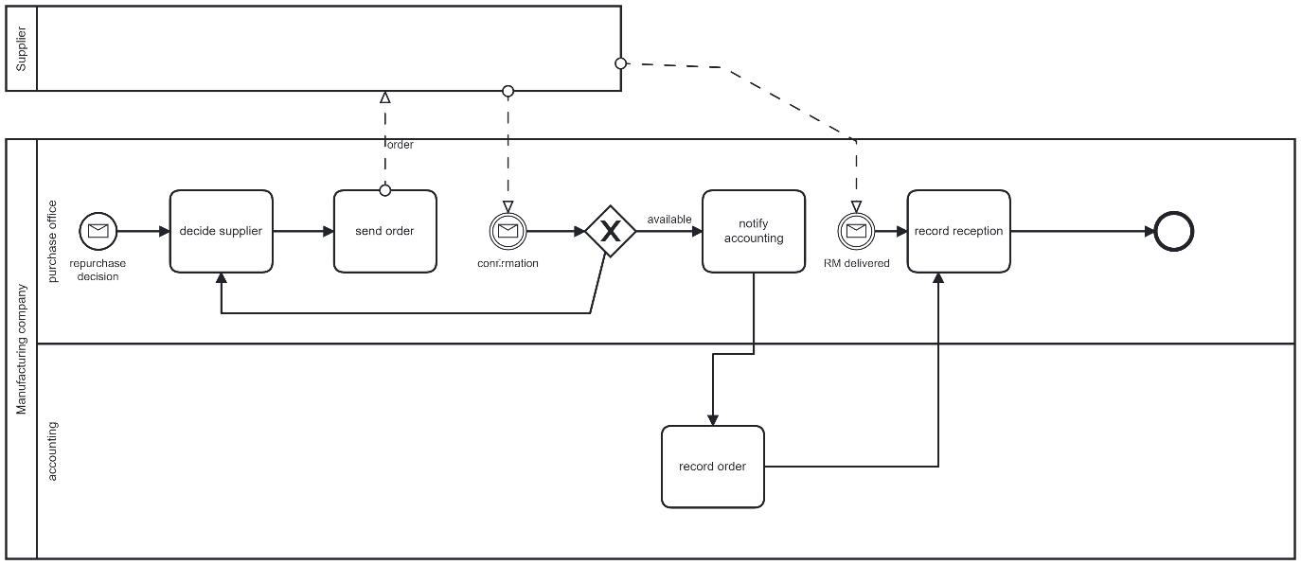

##### RM Quality check

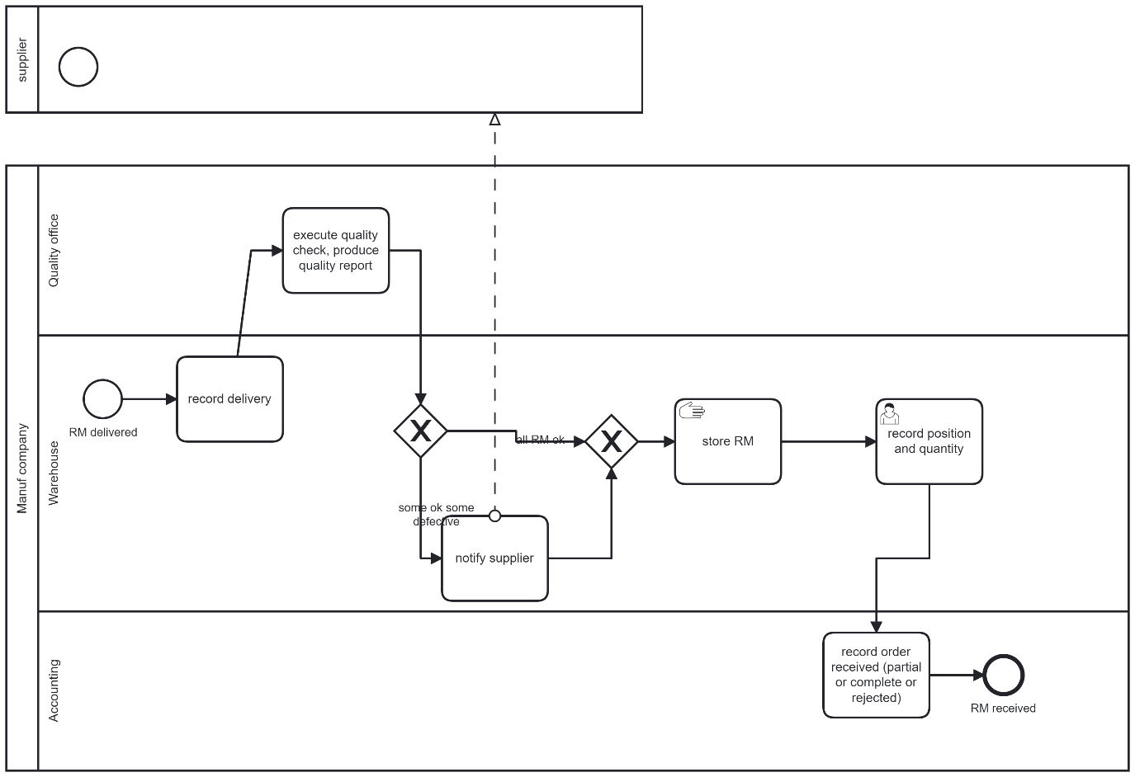

### Conceptual model

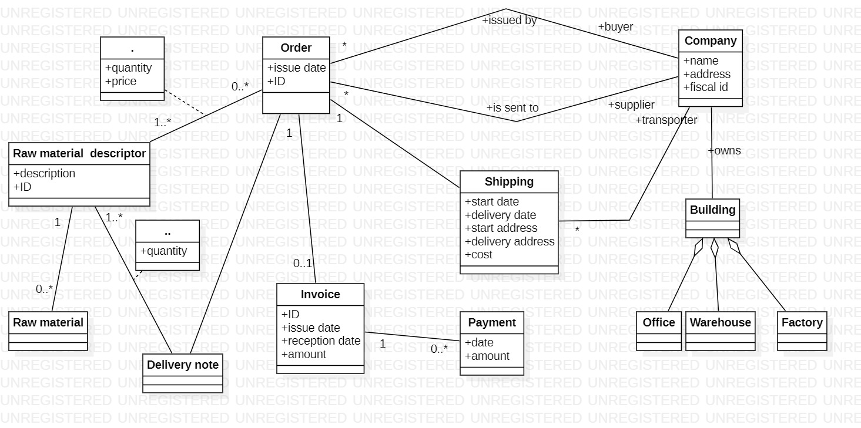

Order is the core concept, all others come around it.

(Building is not really relevant, was made as an example of aggregation)

Additional problem: The same raw material typically has two IDS: one for the buyer, one for the supplier. The model above has only one ID for Raw material descriptor